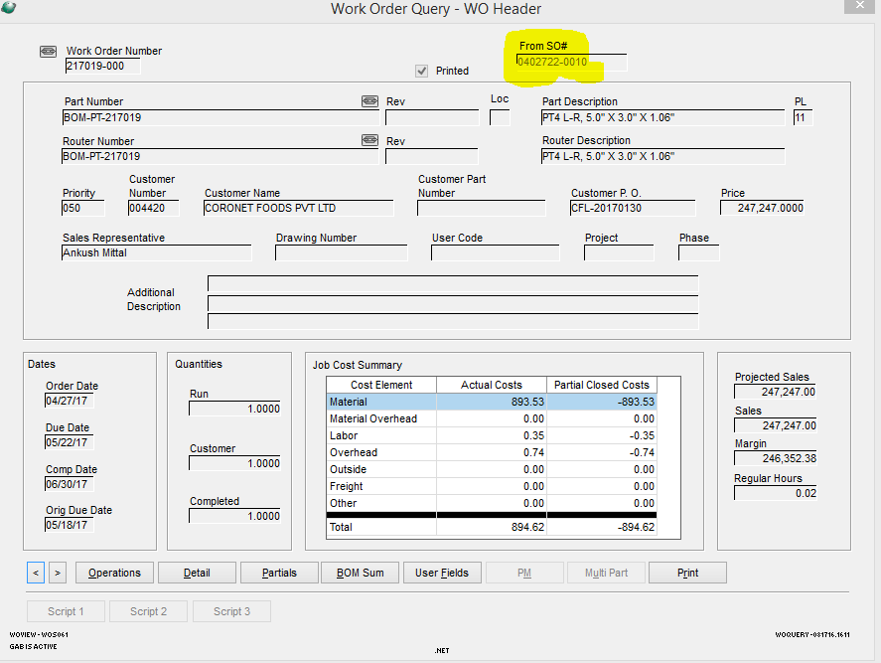

This was a field added by Trent Maynard when he was onsite at one point. It looks up the SO number tied to a WO from the V_ORDER_TO_WO table. Looking at the GAB script it uses the following query:

“select order_no, order_line from v_order_to_wo where job = '217019' and suffix = '000'”

It also seems to have some bugs, it will display a SO from other records at times, I can’t reproduce the same SO to WO tie now but this was the field I saw that link before sending it to you. I am seeing the 217019 WO to 0402722 SO tie though in the table.